|  |  |
| --- | --- |
| *Pacific Gas and Electric Company* | |
| Patch 7.5.5 Installation Guide | |
|  |  |
|  |  |
| Project | ED AM/GIS |
|  |  |
| Prepared by | Rob Rader |
| Date | 7/20/2013 |
| Version | 1.3 |
| Version Type | Final |

|  |  |  |  |
| --- | --- | --- | --- |
| Revision History | | | |
| Document # | Date | Author | Summary of Changes |
| 1.0 | July 17, 2013 | Rob Rader | Initial Document Creation |
| 1.1-1.3 | July 19th | Rob Rader | Changes to reflect Stacking issues, domain changes and the relationship drop create. |
|  |  |  |  |

# Introduction

## Purpose

This document is intended to detail the implementation and configuration steps required to implement the ED AM/GIS 7.5.5 data model release. This document describes the various configuration aspects required to complete any manual or automatic patch associated with this release. Each section in this document contains the steps required to patch the system in production.

## Terms Used

|  |  |
| --- | --- |
| OOTB | Out of the box. Unmodified from the commercial version. |
| TFS | Team Foundation Server |

## TFS Reference

The change requests that constitue the 7.5.5 data model release may be found in TFS using the following information.

|  |  |  |  |
| --- | --- | --- | --- |
| Ticket # | | Work Item Type | Title |
| [8872](http://edappgistfsprd1:8080/tfs/ElectricDistCollection/EDAMGIS/_workItems#_a=edit&id=8872) | | Change Request | Master 7.5.5 Data Model Changes |
| [4561](http://edappgistfsprd1:8080/tfs/ElectricDistCollection/EDAMGIS/_workItems#_a=edit&id=4561) | Change Request | Correct Backward Label on the SupportStructure_JointOwner Relationship |
| [4784](http://edappgistfsprd1:8080/tfs/ElectricDistCollection/EDAMGIS/_workItems#_a=edit&id=4784) | Change Request | Need to add "UNKNOWN" to the JobPrefixCode Domain, or make the InstallJobPrefix optional |
| [8923](http://edappgistfsprd1:8080/tfs/ElectricDistCollection/EDAMGIS/_workItems#_a=edit&id=8923) | Change Request | Change Label Expression For SupportStructureAnno Job Annotation Class |
| [8924](http://edappgistfsprd1:8080/tfs/ElectricDistCollection/EDAMGIS/_workItems#_a=edit&id=8924) | Change Request | Change Label Expression For StepDownAnno Job Annotation Class |
| [8926](http://edappgistfsprd1:8080/tfs/ElectricDistCollection/EDAMGIS/_workItems#_a=edit&id=8926) | Change Request | Change Label Expression For SecUGConductorAnno Job Annotation Class |
| [8927](http://edappgistfsprd1:8080/tfs/ElectricDistCollection/EDAMGIS/_workItems#_a=edit&id=8927) | Change Request | Change Label Expression For SecOHConductorAnno Job Annotation Class |
| [8928](http://edappgistfsprd1:8080/tfs/ElectricDistCollection/EDAMGIS/_workItems#_a=edit&id=8928) | Change Request | Change Label Expression For PriUGConductorAnno Job Annotation Class |
| [8929](http://edappgistfsprd1:8080/tfs/ElectricDistCollection/EDAMGIS/_workItems#_a=edit&id=8929) | Change Request | Change Label Expression For PriOHConductorAnno Job Annotation Class |
| [8930](http://edappgistfsprd1:8080/tfs/ElectricDistCollection/EDAMGIS/_workItems#_a=edit&id=8930) | Change Request | Add FuseAnno Job Annotation Class |
| [8931](http://edappgistfsprd1:8080/tfs/ElectricDistCollection/EDAMGIS/_workItems#_a=edit&id=8931) | Change Request | Change Label Expression For DynamicProtectiveDeviceAnno Job Annotation Class |
| [8932](http://edappgistfsprd1:8080/tfs/ElectricDistCollection/EDAMGIS/_workItems#_a=edit&id=8932) | Change Request | Change Label Expression For DCRectifierAnno Job Annotation Class |
| [8933](http://edappgistfsprd1:8080/tfs/ElectricDistCollection/EDAMGIS/_workItems#_a=edit&id=8933) | Change Request | Change Label Expression For VoltageRegulatorAnno Job Annotation Class |
| [8934](http://edappgistfsprd1:8080/tfs/ElectricDistCollection/EDAMGIS/_workItems#_a=edit&id=8934) | Change Request | Change Label Expression For TransformerAnno Job Annotation Class |
| [8935](http://edappgistfsprd1:8080/tfs/ElectricDistCollection/EDAMGIS/_workItems#_a=edit&id=8935) | Change Request | Change Label Expression For CapacitorBankAnno Job Annotation … |
| [8936](http://edappgistfsprd1:8080/tfs/ElectricDistCollection/EDAMGIS/_workItems#_a=edit&id=8936) | Change Request | Change Label Expression For SwitchAnno Job Annotation Class |
| [8981](http://edappgistfsprd1:8080/tfs/ElectricDistCollection/EDAMGIS/_workItems#_a=edit&id=8981) | Change Request | Add PEC code to the “Conductor Insulation – UG” domain |

## External Documents

Referenced are any external configuration documents or exports. These are documents that contain more detailed information about configuring a system or documents that can be loaded into an application to perform the configuration detailed in this document.

* *No external documents*

## Summary of Steps to Complete Patch

These are the high-level steps to complete the installation and configuration of the data model patch. Use this table as a guide for completing the installation. Links are provided that can lead either within the document for detailed explanations or to external sites such as Sharepoint.

|  |  |  |  |
| --- | --- | --- | --- |
|  | **Step Name** | **Description** | **Document Link** |
|  | Configure ArcCatalog Connection | Connect to the target database as *edgis* in ArcCatalog, creating a new named connection if necessary. | Set Up ArcCatalog Connection |
|  | Modify CapacitorBankAnno | Modify the job class in the annotation to filter 0,’FIF’, ‘PM’ and ‘CEDSA’ | Modify CapacitorBankAnno |
|  | Modify DC Rectifier Anno | Modify the job class in the annotation to filter 0,’FIF’, ‘PM’ and ‘CEDSA’ | Modify DC Rectifier Anno |
|  | Modify DynamicProtectiveDevice Anno | Modify the job class in the annotation to filter 0,’FIF’, ‘PM’ and ‘CEDSA’ | Modify DynamicProtectiveDevice Anno |
|  | Modify Fuse Anno | Modify the job class in the annotation to filter 0,’FIF’, ‘PM’ and ‘CEDSA’ | Modify Fuse Anno |
|  | Modify PriOHConductor Anno | Modify the job class in the annotation to filter 0,’FIF’, ‘PM’ and ‘CEDSA’ | Modify PriOHConductor Anno |
|  | Modify PriUGConductor Anno | Modify the job class in the annotation to filter 0,’FIF’, ‘PM’ and ‘CEDSA’ | Modify PriUGConductor Anno |
|  | Modify SecOHConductor Anno | Modify the job class in the annotation to filter 0,’FIF’, ‘PM’ and ‘CEDSA’ | Modify SecOHConductor Anno |
|  | Modify SecUGConductor Anno | Modify the job class in the annotation to filter 0,’FIF’, ‘PM’ and ‘CEDSA’ | Modify SecUGConductor Anno |
|  | Modify StepDown Anno | Modify the job class in the annotation to filter 0,’FIF’, ‘PM’ and ‘CEDSA’ | Modify StepDown Anno |
|  | Modify SupportStructure Anno | Modify the job class in the annotation to filter 0,’FIF’, ‘PM’ and ‘CEDSA’ | Modify SupportStructure Anno |
|  | Modify Switch Anno | Modify the job class in the annotation to filter 0,’FIF’, ‘PM’ and ‘CEDSA’ | Modify Switch Anno |
|  | Modify Transformer Anno | Modify the job class in the annotation to filter 0,’FIF’, ‘PM’ and ‘CEDSA’ | Modify Transformer Anno |
|  | Modify VoltageRegulator Anno | Modify the job class in the annotation to filter 0,’FIF’, ‘PM’ and ‘CEDSA’ | Modify VoltageRegulator Anno |
|  | Drop and Create Relationship | SupportStructure_JointOwner | Drop and Create Relationship |
|  | Add the value of UNK into the Job Prefix Code Domain | JobPrefixCode domain  Code: UNK  Description: UNK | Add the value of UNK into the Job Prefix Code Domain |
|  | Add Code/Value of PEC to Domain “Conductor Insulation - UG” | “Conductor Insulation - UG” domain  Code: PEC  Description: PEC | Add Code/Value of PEC to Domain “Conductor Insulation - UG” |

# Set Up ArcCatalog Connection

Set up a connection in ArcCatalog to use for both automatic and manual patching.

1. Open ArcCatalog.
2. Within the Catalog Tree, expand “Database Connections” and click “Add Spatial Database Connection”.  
     
   
3. Fill in the attributes as shown below. Modify as necessary to reach the correct database.  
     
   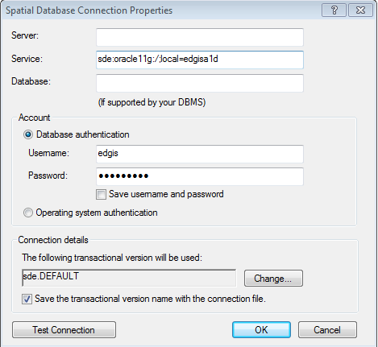

sde:oracle11g:/;local=edgisg1d

1. Click “OK”.
2. The connection will appear on the right side of the window in the Contents tab. Rename the connection appropriately.  
     
   
3. If the full path of this connection is needed, retrieve from in the following default location (path may vary based on installation and operating system):  
   C:\Users\[LAN ID]\AppData\Roaming\ESRI\Desktop10.0\ArcCatalog\[FILENAME].sde
4. Double-click on the connection within ArcCatalog to open it.

# Modify Annotation Feature Classes

## Modify CapacitorBankAnno

1. Open ArcCatalog.
2. Within the Catalog Tree, expand “Database Connections” and open the active connection for this process (as defined in section 2).
3. Within the ElectricDataset, right-click on the “CapacitorBankAnno” annotation feature class and click “Properties”.
4. Click on the “Annotation Classes” tab.  
     
   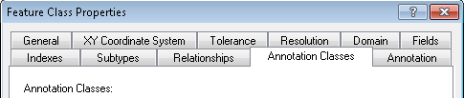

1. Click on the *Job* annotation class to begin modifying its attributes.  
   1. Make sure the stack label check box is unselected.

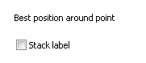

* 1. Click “Expression” next to the Label Field dropdown.

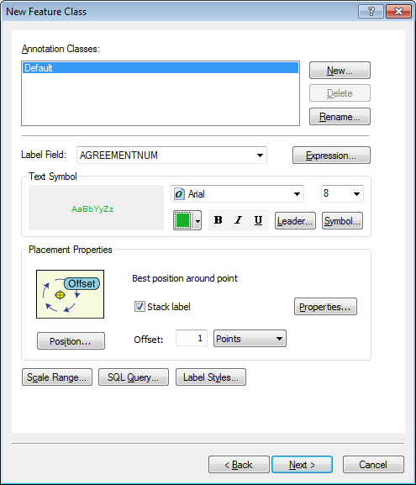

* 1. Ensure that the “Display coded value description” checkbox is selected, match the label text with the text below, click verify, and then click “OK”.  
     *(Note: the contents of the expression field below may be copied)*

## 

Function FindLabel ( [INSTALLJOBPREFIX] , [INSTALLJOBNUMBER] , [INSTALLJOBYEAR] )

myString = ""

if isNull( [INSTALLJOBNUMBER] ) or [INSTALLJOBNUMBER] = "0" or _

instr(ucase( [INSTALLJOBNUMBER] ), "CEDSA") then

else

if left(ucase( [INSTALLJOBPREFIX] ), 3) <> "UNK" and ucase( [INSTALLJOBPREFIX] ) <> "FIF" and _

len( [INSTALLJOBPREFIX] ) > 0 then

myString = [INSTALLJOBPREFIX]

end if

if len( [INSTALLJOBYEAR] ) > 0 then

if len( [INSTALLJOBYEAR] ) = 4 then

FindLabel = myString + [INSTALLJOBNUMBER] + " '"+ right( [INSTALLJOBYEAR] ,2)

elseif len( [INSTALLJOBYEAR] ) = 2 then

FindLabel = myString + [INSTALLJOBNUMBER] + " '"+ [INSTALLJOBYEAR]

end if

else

FindLabel = myString + [INSTALLJOBNUMBER]

end if

end if

End Function

## Modify DCRectifierAnno

1. Open ArcCatalog.
2. Within the Catalog Tree, expand “Database Connections” and open the active connection for this process (as defined in section 2).
3. Within the ElectricDataset, right-click on the “DCRectifierAnno” annotation feature class and click “Properties”.
4. Click on the “Annotation Classes” tab.  
     
   

1. Click on the *Job* annotation class to begin modifying its attributes.  
   1. Click “Expression” next to the Label Field dropdown.



* 1. Ensure that the “Display coded value description” checkbox is selected, match the label text with the text below, click verify, and then click “OK”.  
     *(Note: the contents of the expression field below may be copied)*

## 

Function FindLabel ( [INSTALLJOBPREFIX] , [INSTALLJOBNUMBER] , [INSTALLJOBYEAR] )

myString = ""

if isNull( [INSTALLJOBNUMBER] ) or [INSTALLJOBNUMBER] = "0" or _

instr(ucase( [INSTALLJOBNUMBER] ), "CEDSA") then

else

if left(ucase( [INSTALLJOBPREFIX]), 3 ) <> "UNK" and _

ucase( [INSTALLJOBPREFIX] ) <> "FIF" and _

len( [INSTALLJOBPREFIX] ) > 0 then

myString = [INSTALLJOBPREFIX]

end if

if len( [INSTALLJOBYEAR] ) > 0 then

if len( [INSTALLJOBYEAR] ) = 4 then

FindLabel = myString + [INSTALLJOBNUMBER] + " '"+ right( [INSTALLJOBYEAR] ,2)

elseif len( [INSTALLJOBYEAR] ) = 2 then

FindLabel = myString + [INSTALLJOBNUMBER] + " '"+ [INSTALLJOBYEAR]

end if

else

FindLabel = myString + [INSTALLJOBNUMBER]

end if

end if

End Function

## Modify DynamicProtectiveDeviceAnno

1. Open ArcCatalog.
2. Within the Catalog Tree, expand “Database Connections” and open the active connection for this process (as defined in section 2).
3. Within the ElectricDataset, right-click on the “DynamicProtectiveDeviceAnno” annotation feature class and click “Properties”.
4. Click on the “Annotation Classes” tab.  
     
   
5. Click on the *Job* annotation class to begin modifying its attributes.  
   1. Uncheck the Stack Label Check box



* 1. Set the Offset = 9 Points



* 1. Click “Expression” next to the Label Field dropdown.



* 1. Ensure that the “Display coded value description” checkbox is selected, match the label text with the text below, click verify, and then click “OK”.  
     *(Note: the contents of the expression field below may be copied)*

## 

Function FindLabel ( [InstallJobPrefix], [InstallJobNumber], [InstallJobYear], [SUBTYPECD], [SWITCHMODEIDC] )

myString = ""

if isNull( [INSTALLJOBNUMBER] ) or [INSTALLJOBNUMBER] = "0" or _

instr(ucase( [INSTALLJOBNUMBER] ), "CEDSA") then

else

if left(ucase( [INSTALLJOBPREFIX]), 3 ) <> "UNK" and _

ucase( [INSTALLJOBPREFIX] ) <> "FIF" and _

len( [INSTALLJOBPREFIX] ) > 0 then

myString = [INSTALLJOBPREFIX]

end if

if len( [INSTALLJOBYEAR] ) > 0 then

if len( [INSTALLJOBYEAR] ) = 4 then

myString = myString + [INSTALLJOBNUMBER] + " '"+ right( [INSTALLJOBYEAR] ,2)

elseif len( [INSTALLJOBYEAR] ) = 2 then

myString = myString + [INSTALLJOBNUMBER] + " '"+ [INSTALLJOBYEAR]

end if

else

myString = myString + [INSTALLJOBNUMBER]

end if

end if

If [SubtypeCD] = "Recloser" or [SubtypeCD] = "Sectionalizer" or [SubtypeCD] = "Interrupter" then

If [SubtypeCD] <> "Interrupter" or [SWITCHMODEIDC] <> "Yes" or isNull( [SWITCHMODEIDC] ) then

FindLabel = myString + vbCrLf + chr(129)

else

FindLabel = myString

end if

else

FindLabel = myString + vbCrLf + chr(129) + vbCrLf + chr(129)

end if

End Function

## Modify FuseAnno

1. Open ArcCatalog.
2. Within the Catalog Tree, expand “Database Connections” and open the active connection for this process (as defined in section 2).
3. Within the ElectricDataset, right-click on the “FuseAnno” annotation feature class and click “Properties”.
4. Click on the “Annotation Classes” tab.  
     
   

1. **Create** a new Annotation Class called Job.

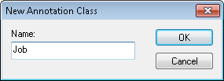

1. Click on the *Job* annotation class to begin modifying its attributes.  
   1. Click “Expression” next to the Label Field dropdown.



* 1. Ensure that the “Display coded value description” checkbox is selected, match the label text with the text below, click verify, and then click “OK”.  
     *(Note: the contents of the expression field below may be copied)*

## 

Function FindLabel ( [INSTALLJOBPREFIX], [INSTALLJOBNUMBER], [INSTALLJOBYEAR] )

myString = ""

if isNull( [INSTALLJOBNUMBER] ) or [INSTALLJOBNUMBER] = "0" or _

instr(ucase( [INSTALLJOBNUMBER] ), "CEDSA") then

else

if left(ucase( [INSTALLJOBPREFIX]), 3 ) <> "UNK" and _

ucase( [INSTALLJOBPREFIX] ) <> "FIF" and _

len( [INSTALLJOBPREFIX] ) > 0 then

myString = [INSTALLJOBPREFIX]

end if

if len( [INSTALLJOBYEAR] ) > 0 then

if len( [INSTALLJOBYEAR] ) = 4 then

FindLabel = myString + [INSTALLJOBNUMBER] + " '"+ right( [INSTALLJOBYEAR] ,2)

elseif len( [INSTALLJOBYEAR] ) = 2 then

FindLabel = myString + [INSTALLJOBNUMBER] + " '"+ [INSTALLJOBYEAR]

end if

else

FindLabel = myString + [INSTALLJOBNUMBER]

end if

end if

End Function

Function FindLabel ( [INSTALLJOBPREFIX], [INSTALLJOBNUMBER], [INSTALLJOBYEAR] )

myString = ""

if isNull( [INSTALLJOBNUMBER] ) or [INSTALLJOBNUMBER] = "0" or _

instr(ucase( [INSTALLJOBNUMBER] ), "CEDSA") then

else

if left(ucase( [INSTALLJOBPREFIX]), 3 ) <> "UNK" and _

ucase( [INSTALLJOBPREFIX] ) <> "FIF" and _

len( [INSTALLJOBPREFIX] ) > 0 then

myString = [INSTALLJOBPREFIX]

end if

if len( [INSTALLJOBYEAR] ) > 0 then

if len( [INSTALLJOBYEAR] ) = 4 then

FindLabel = myString + [INSTALLJOBNUMBER] + " '"+ right( [INSTALLJOBYEAR] ,2)

elseif len( [INSTALLJOBYEAR] ) = 2 then

FindLabel = myString + [INSTALLJOBNUMBER] + " '"+ [INSTALLJOBYEAR]

end if

else

FindLabel = myString + [INSTALLJOBNUMBER]

end if

end if

End Function

* 1. Set the size of the font to 8
  2. Set the Font to Arial

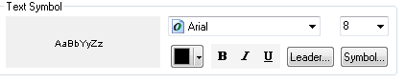

* 1. Select the Symbol button
  2. Hit the edit symbol button

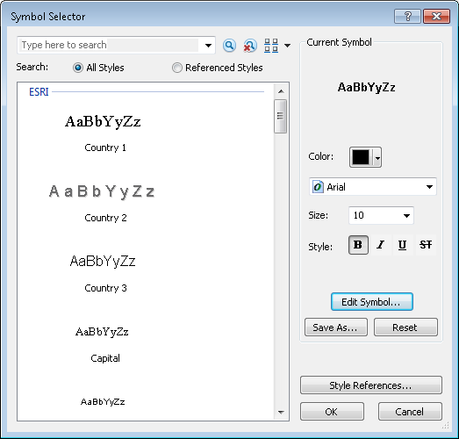

* 1. Set the X- Offset to 5 and Set the Y Offset to -5

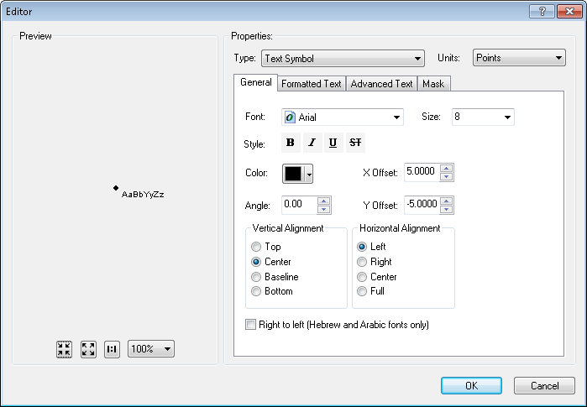

* 1. Make sure the stack label check box is unselected.



1. Modify the Fuse Annotation class of default and change the offset of the symbol:
   1. Select the sybol edit button.

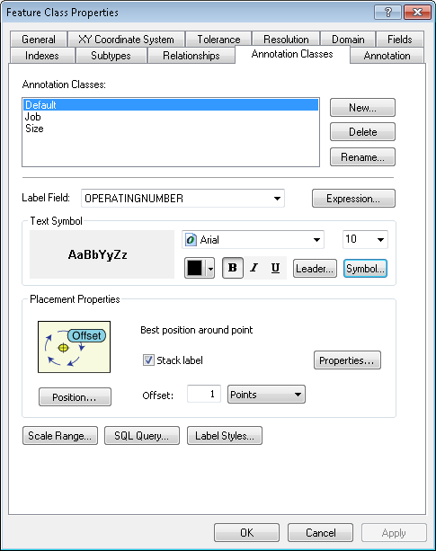

* 1. Hit the edit symbol button.



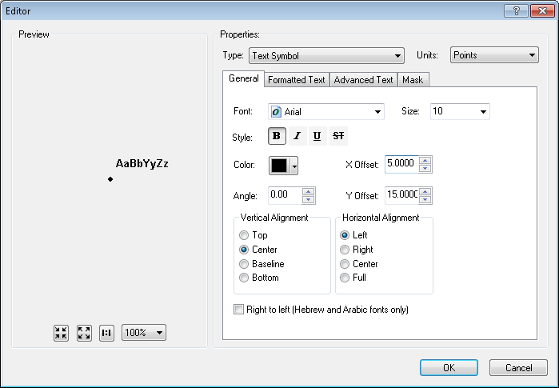

* 1. Change to X=5 and Hit OK

1. Modify the Fuse Annotation class of Size and change the offset of the symbol:
   1. Select the sybol edit button.

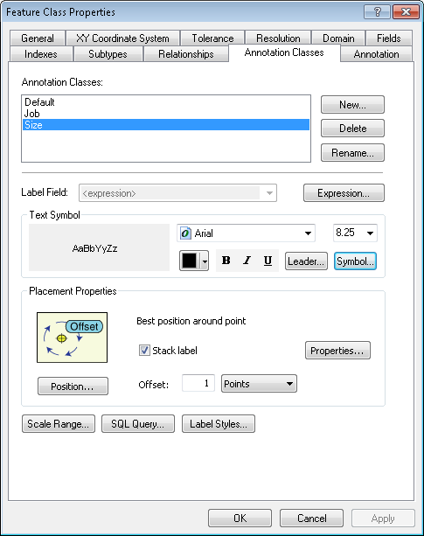

* 1. Hit the edit symbol button.

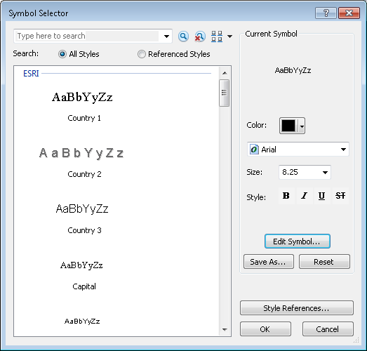

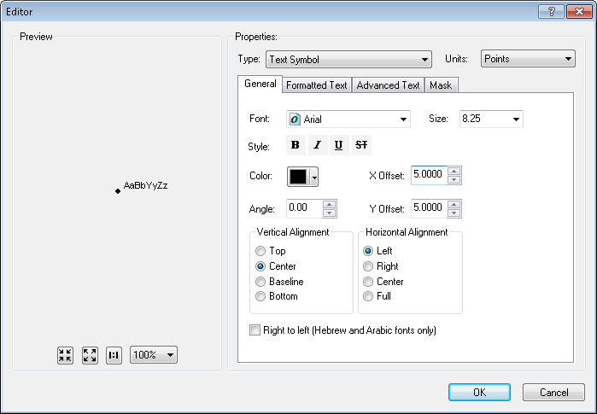

* 1. Change to X=5 and Hit OK

## Modify PriOHConductorAnno

1. Open ArcCatalog.
2. Within the Catalog Tree, expand “Database Connections” and open the active connection for this process (as defined in section 2).
3. Within the ElectricDataset, right-click on the “PriOHConductorAnno” annotation feature class and click “Properties”.
4. Click on the “Annotation Classes” tab.  
     
   

1. Click on the *Job* annotation class to begin modifying its attributes.  
   1. Make sure the stack label check box is unselected.



* 1. Click “Expression” next to the Label Field dropdown.



* 1. Ensure that the “Display coded value description” checkbox is selected, match the label text with the text below, click verify, and then click “OK”.  
     *(Note: the contents of the expression field below may be copied)*

## 

Function FindLabel ( [INSTALLJOBPREFIX] , [INSTALLJOBNUMBER] , [INSTALLJOBYEAR] )

myString = ""

if isNull( [INSTALLJOBNUMBER] ) or [INSTALLJOBNUMBER] = "0" or _

instr(ucase( [INSTALLJOBNUMBER] ), "CEDSA") then

else

if left(ucase( [INSTALLJOBPREFIX]), 3 ) <> "UNK" and _

ucase( [INSTALLJOBPREFIX] ) <> "FIF" and _

len( [INSTALLJOBPREFIX] ) > 0 then

myString = [INSTALLJOBPREFIX]

end if

if len( [INSTALLJOBYEAR] ) > 0 then

if len( [INSTALLJOBYEAR] ) = 4 then

FindLabel = myString + [INSTALLJOBNUMBER] + " '"+ right( [INSTALLJOBYEAR] ,2)

elseif len( [INSTALLJOBYEAR] ) = 2 then

FindLabel = myString + [INSTALLJOBNUMBER] + " '"+ [INSTALLJOBYEAR]

end if

else

FindLabel = myString + [INSTALLJOBNUMBER]

end if

end if

End FunctionEnd Function

## Modify PriUGConductorAnno

1. Open ArcCatalog.
2. Within the Catalog Tree, expand “Database Connections” and open the active connection for this process (as defined in section 2).
3. Within the ElectricDataset, right-click on the “PriUGConductorAnno” annotation feature class and click “Properties”.
4. Click on the “Annotation Classes” tab.  
     
   

1. Click on the *Job* annotation class to begin modifying its attributes.  
   1. Make sure the stack label check box is unselected.



* 1. Click “Expression” next to the Label Field dropdown.



* 1. Ensure that the “Display coded value description” checkbox is selected, match the label text with the text below, click verify, and then click “OK”.  
     *(Note: the contents of the expression field below may be copied)*

## 

Function FindLabel ( [INSTALLJOBPREFIX] , [INSTALLJOBNUMBER] , [INSTALLJOBYEAR] )

myString = ""

if isNull( [INSTALLJOBNUMBER] ) or [INSTALLJOBNUMBER] = "0" or _

instr(ucase( [INSTALLJOBNUMBER] ), "CEDSA") then

else

if left(ucase( [INSTALLJOBPREFIX]), 3 ) <> "UNK" and _

ucase( [INSTALLJOBPREFIX] ) <> "FIF" and _

len( [INSTALLJOBPREFIX] ) > 0 then

myString = [INSTALLJOBPREFIX]

end if

if len( [INSTALLJOBYEAR] ) > 0 then

if len( [INSTALLJOBYEAR] ) = 4 then

FindLabel = myString + [INSTALLJOBNUMBER] + " '"+ right( [INSTALLJOBYEAR] ,2)

elseif len( [INSTALLJOBYEAR] ) = 2 then

FindLabel = myString + [INSTALLJOBNUMBER] + " '"+ [INSTALLJOBYEAR]

end if

else

FindLabel = myString + [INSTALLJOBNUMBER]

end if

end if

End Function

## Modify SecOHConductorAnno

1. Open ArcCatalog.
2. Within the Catalog Tree, expand “Database Connections” and open the active connection for this process (as defined in section 2).
3. Within the ElectricDataset, right-click on the “SecOHConductorAnno” annotation feature class and click “Properties”.
4. Click on the “Annotation Classes” tab.  
     
   

1. Click on the *Job* annotation class to begin modifying its attributes.  
   1. Make sure the stack label check box is unselected.



* 1. Click “Expression” next to the Label Field dropdown.



* 1. Ensure that the “Display coded value description” checkbox is selected, match the label text with the text below, click verify, and then click “OK”.  
     *(Note: the contents of the expression field below may be copied)*

## 

Function FindLabel ( [INSTALLJOBPREFIX] , [INSTALLJOBNUMBER] , [INSTALLJOBYEAR] )

myString = ""

if isNull( [INSTALLJOBNUMBER] ) or [INSTALLJOBNUMBER] = "0" or _

instr(ucase( [INSTALLJOBNUMBER] ), "CEDSA") then

else

if left(ucase( [INSTALLJOBPREFIX]), 3 ) <> "UNK" and _

ucase( [INSTALLJOBPREFIX] ) <> "FIF" and _

len( [INSTALLJOBPREFIX] ) > 0 then

myString = [INSTALLJOBPREFIX]

end if

if len( [INSTALLJOBYEAR] ) > 0 then

if len( [INSTALLJOBYEAR] ) = 4 then

FindLabel = myString + [INSTALLJOBNUMBER] + " '"+ right( [INSTALLJOBYEAR] ,2)

elseif len( [INSTALLJOBYEAR] ) = 2 then

FindLabel = myString + [INSTALLJOBNUMBER] + " '"+ [INSTALLJOBYEAR]

end if

else

FindLabel = myString + [INSTALLJOBNUMBER]

end if

end if

End Function

## Modify SecUGConductorAnno

1. Open ArcCatalog.
2. Within the Catalog Tree, expand “Database Connections” and open the active connection for this process (as defined in section 2).
3. Within the ElectricDataset, right-click on the “SecUGConductorAnno” annotation feature class and click “Properties”.
4. Click on the “Annotation Classes” tab.  
     
   

1. Click on the *Job* annotation class to begin modifying its attributes.  
   1. Make sure the stack label check box is unselected.



* 1. Click “Expression” next to the Label Field dropdown.



* 1. Ensure that the “Display coded value description” checkbox is selected, match the label text with the text below, click verify, and then click “OK”.  
     *(Note: the contents of the expression field below may be copied)*

## 

Function FindLabel ( [INSTALLJOBPREFIX] , [INSTALLJOBNUMBER] , [INSTALLJOBYEAR] )

myString = ""

if isNull( [INSTALLJOBNUMBER] ) or [INSTALLJOBNUMBER] = "0" or _

instr(ucase( [INSTALLJOBNUMBER] ), "CEDSA") then

else

if left(ucase( [INSTALLJOBPREFIX]), 3 ) <> "UNK" and _

ucase( [INSTALLJOBPREFIX] ) <> "FIF" and _

len( [INSTALLJOBPREFIX] ) > 0 then

myString = [INSTALLJOBPREFIX]

end if

if len( [INSTALLJOBYEAR] ) > 0 then

if len( [INSTALLJOBYEAR] ) = 4 then

FindLabel = myString + [INSTALLJOBNUMBER] + " '"+ right( [INSTALLJOBYEAR] ,2)

elseif len( [INSTALLJOBYEAR] ) = 2 then

FindLabel = myString + [INSTALLJOBNUMBER] + " '"+ [INSTALLJOBYEAR]

end if

else

FindLabel = myString + [INSTALLJOBNUMBER]

end if

end if

End Function

## Modify StepDownAnno

1. Open ArcCatalog.
2. Within the Catalog Tree, expand “Database Connections” and open the active connection for this process (as defined in section 2).
3. Within the ElectricDataset, right-click on the “StepDownAnno” annotation feature class and click “Properties”.
4. Click on the “Annotation Classes” tab.  
     
   

1. Click on the *Job* annotation class to begin modifying its attributes.  
   1. Uncheck the Stack Label Check box



* 1. Click “Expression” next to the Label Field dropdown.



* 1. Ensure that the “Display coded value description” checkbox is selected, match the label text with the text below, click verify, and then click “OK”.  
     *(Note: the contents of the expression field below may be copied)*

## 

Function FindLabel( [InstallJobPrefix], [InstallJobNumber], [InstallJobYear], [INSTALLATIONTYPE])

myString = ""

pad = ""

if [INSTALLATIONTYPE] = "Overhead" then

pad = vbCrLf + chr(129)

end if

if isNull( [INSTALLJOBNUMBER] ) or [INSTALLJOBNUMBER] = "0" or _

instr(ucase( [INSTALLJOBNUMBER] ), "CEDSA") then

else

if left(ucase( [INSTALLJOBPREFIX]), 3 ) <> "UNK" and _

ucase( [INSTALLJOBPREFIX] ) <> "FIF" and _

len( [INSTALLJOBPREFIX] ) > 0 then

myString = [INSTALLJOBPREFIX]

end if

if len( [INSTALLJOBYEAR] ) > 0 then

if len( [INSTALLJOBYEAR] ) = 4 then

FindLabel = myString + [INSTALLJOBNUMBER] + " '"+ right( [INSTALLJOBYEAR] ,2) + pad

elseif len( [INSTALLJOBYEAR] ) = 2 then

FindLabel = myString + [INSTALLJOBNUMBER] + " '"+ [INSTALLJOBYEAR] + pad

end if

else

FindLabel = myString + [INSTALLJOBNUMBER] + pad

end if

end if

End Function

## Modify SupportStructureAnno

1. Open ArcCatalog.
2. Within the Catalog Tree, expand “Database Connections” and open the active connection for this process (as defined in section 2).
3. Within the ElectricDataset, right-click on the “SupportStructureAnno” annotation feature class and click “Properties”.
4. Click on the “Annotation Classes” tab.  
     
   

1. Click on the *JobNumber* annotation class to begin modifying its attributes.  
   1. Uncheck the Stack Label Check box



* 1. Click “Expression” next to the Label Field dropdown.



* 1. Ensure that the “Display coded value description” checkbox is selected, match the label text with the text below, click verify, and then click “OK”.  
     *(Note: the contents of the expression field below may be copied)*

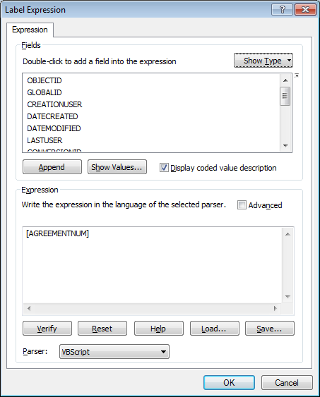

Function FindLabel ( [INSTALLJOBPREFIX] , [INSTALLJOBNUMBER] , [INSTALLJOBYEAR] )

myString = ""

if isNull( [INSTALLJOBNUMBER] ) or [INSTALLJOBNUMBER] = "0" or _

instr(ucase( [INSTALLJOBNUMBER] ), "CEDSA") then

else

if left(ucase( [INSTALLJOBPREFIX]), 3 ) <> "UNK" and _

ucase( [INSTALLJOBPREFIX] ) <> "FIF" and _

len( [INSTALLJOBPREFIX] ) > 0 then

myString = [INSTALLJOBPREFIX]

end if

if len( [INSTALLJOBYEAR] ) > 0 then

if len( [INSTALLJOBYEAR] ) = 4 then

FindLabel = myString + [INSTALLJOBNUMBER] + " '"+ right( [INSTALLJOBYEAR] ,2)

elseif len( [INSTALLJOBYEAR] ) = 2 then

FindLabel = myString + [INSTALLJOBNUMBER] + " '"+ [INSTALLJOBYEAR]

end if

else

FindLabel = myString + [INSTALLJOBNUMBER]

end if

end if

End Function

## Modify SwitchAnno

1. Open ArcCatalog.
2. Within the Catalog Tree, expand “Database Connections” and open the active connection for this process (as defined in section 2).
3. Within the ElectricDataset, right-click on the “SwitchAnno” annotation feature class and click “Properties”.
4. Click on the “Annotation Classes” tab.  
     
   

1. Click on the *Job* annotation class to begin modifying its attributes.  
   1. Confirm that the Stack Label is already unselected for this annotation. If it is not, then please contact IBM Development, Rob Rader or Richard Jasicki.
   2. Click “Expression” next to the Label Field dropdown.



* 1. Ensure that the “Display coded value description” checkbox is selected, match the label text with the text below, click verify, and then click “OK”.  
     *(Note: the contents of the expression field below may be copied)*



Function FindLabel ( [INSTALLJOBPREFIX] , [INSTALLJOBNUMBER] , [INSTALLJOBYEAR] )

myString = ""

if isNull( [INSTALLJOBNUMBER] ) or [INSTALLJOBNUMBER] = "0" or _

instr(ucase( [INSTALLJOBNUMBER] ), "CEDSA") then

else

if left(ucase( [INSTALLJOBPREFIX]), 3 ) <> "UNK" and _

ucase( [INSTALLJOBPREFIX] ) <> "FIF" and _

len( [INSTALLJOBPREFIX] ) > 0 then

myString = [INSTALLJOBPREFIX]

end if

if len( [INSTALLJOBYEAR] ) > 0 then

if len( [INSTALLJOBYEAR] ) = 4 then

FindLabel = myString + [INSTALLJOBNUMBER] + " '"+ right( [INSTALLJOBYEAR] ,2)

elseif len( [INSTALLJOBYEAR] ) = 2 then

FindLabel = myString + [INSTALLJOBNUMBER] + " '"+ [INSTALLJOBYEAR]

end if

else

FindLabel = myString + [INSTALLJOBNUMBER]

end if

end if

End Function

## Modify TransformerAnno

1. Open ArcCatalog.
2. Within the Catalog Tree, expand “Database Connections” and open the active connection for this process (as defined in section 2).
3. Within the ElectricDataset, right-click on the “TransformerAnno” annotation feature class and click “Properties”.
4. Click on the “Annotation Classes” tab.  
     
   

1. Click on the *Job* annotation class to begin modifying its attributes.  
   1. Uncheck the Stack Label Check box



* 1. Click “Expression” next to the Label Field dropdown.



* 1. Ensure that the “Display coded value description” checkbox is selected, match the label text with the text below, click verify, and then click “OK”.  
     *(Note: the contents of the expression field below may be copied)*



Function FindLabel ( [InstallJobPrefix], [InstallJobNumber], [InstallJobYear], [LABELTEXT], [SUBTYPECD], [INSTALLATIONTYPE], [CGC12])

pos1 = InStr (1, [LABELTEXT], chr(10))

if pos1 > 0 then

pos2 = InStr(pos1 + 1, [LABELTEXT], chr(10))

else

pos2 = -1

end if

if ( pos1 > 0) and (pos2 > 0) and (pos2 - pos1 > 1) then

lineCount = 3

elseif pos1 > 0 then

lineCount = 2

else

lineCount = 1

end if

myString = ""

if isNull( [INSTALLJOBNUMBER] ) or [INSTALLJOBNUMBER] = "0" or _

instr(ucase( [INSTALLJOBNUMBER] ), "CEDSA") then

else

if left(ucase( [INSTALLJOBPREFIX]), 3 ) <> "UNK" and _

ucase( [INSTALLJOBPREFIX] ) <> "FIF" and _

len( [INSTALLJOBPREFIX] ) > 0 then

myString = [INSTALLJOBPREFIX]

end if

if len( [INSTALLJOBYEAR] ) > 0 then

if len( [INSTALLJOBYEAR] ) = 4 then

myString = myString + [INSTALLJOBNUMBER] + " '"+ right( [INSTALLJOBYEAR] ,2)

elseif len( [INSTALLJOBYEAR] ) = 2 then

myString = myString + [INSTALLJOBNUMBER] + " '"+ [INSTALLJOBYEAR]

end if

else

myString = myString + [INSTALLJOBNUMBER]

end if

end if

if [SUBTYPECD] = "Distribution Overhead" or _

([SUBTYPECD] = "Equipment" and [INSTALLATIONTYPE] = "Overhead") or _

([SUBTYPECD] = "Street Light" and [INSTALLATIONTYPE] = "Overhead") or _

([SUBTYPECD] = "Secondary" and [INSTALLATIONTYPE] = "Overhead") then

if LineCount = 3 then

FindLabel = myString

elseif LineCount = 2 then

FindLabel = myString + vbCrLf + chr(129)

else

FindLabel = myString + vbCrLf + chr(129) + vbCrLf + chr(129)

end if

else

if LineCount = 3 then

FindLabel = myString

elseif LineCount = 2 then

FindLabel = myString + vbCrLf + chr(129)

else

FindLabel = myString + vbCrLf + chr(129) + vbCrLf + chr(129)

end if

end if

End Function

## Modify VoltageRegulatorAnno

1. Open ArcCatalog.
2. Within the Catalog Tree, expand “Database Connections” and open the active connection for this process (as defined in section 2).
3. Within the ElectricDataset, right-click on the “VoltageRegulatorAnno” annotation feature class and click “Properties”.
4. Click on the “Annotation Classes” tab.  
     
   

1. Click on the *Job* annotation class to begin modifying its attributes.  
   1. Confirm that the Stack Label is already unselected for this annotation. If it is not, then please contact IBM Development, Rob Rader or Richard Jasicki.
   2. Click “Expression” next to the Label Field dropdown.



* 1. Ensure that the “Display coded value description” checkbox is selected, match the label text with the text below, click verify, and then click “OK”.  
     *(Note: the contents of the expression field below may be copied)*



Function FindLabel ( [INSTALLJOBPREFIX] , [INSTALLJOBNUMBER] , [INSTALLJOBYEAR] )

myString = ""

if isNull( [INSTALLJOBNUMBER] ) or [INSTALLJOBNUMBER] = "0" or _

instr(ucase( [INSTALLJOBNUMBER] ), "CEDSA") then

else

if left(ucase( [INSTALLJOBPREFIX]), 3 ) <> "UNK" and _

ucase( [INSTALLJOBPREFIX] ) <> "FIF" and _

len( [INSTALLJOBPREFIX] ) > 0 then

myString = [INSTALLJOBPREFIX]

end if

if len( [INSTALLJOBYEAR] ) > 0 then

if len( [INSTALLJOBYEAR] ) = 4 then

FindLabel = myString + [INSTALLJOBNUMBER] + " '"+ right( [INSTALLJOBYEAR] ,2)

elseif len( [INSTALLJOBYEAR] ) = 2 then

FindLabel = myString + [INSTALLJOBNUMBER] + " '"+ [INSTALLJOBYEAR]

end if

else

FindLabel = myString + [INSTALLJOBNUMBER]

end if

end if

End Function

# Drop and create relationship: SupportStructure_JointOwner

[**Change Request 4561:**](http://edappgistfsprd1:8080/tfs/ElectricDistCollection/EDAMGIS/_workitems/edit/4561)**Correct Backward Label on the SupportStructure_JointOwner Relationship class**

**PREREQUISITE: Must have the ESRI Relationship Cardinality patch from Vinay. Else this step is useless.**

1. Select the Relationship class EDGIS.SupportStructure_JointOwner

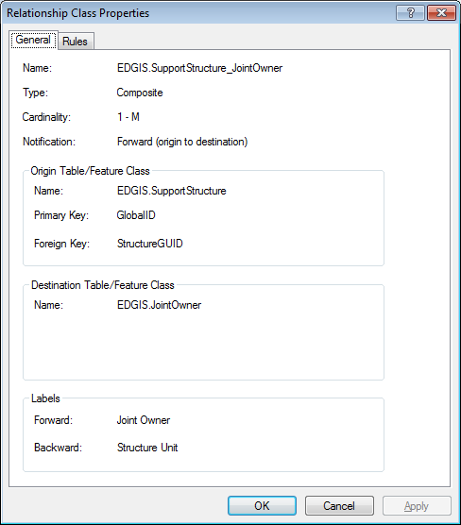

1. Delete relationship

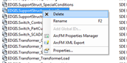

1. Create New relationship

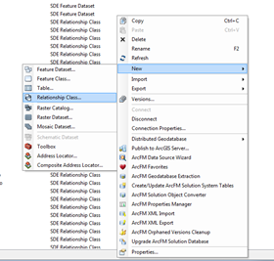

1. Enter “Name of the relationship class:” = SupportStructure_JointOwner
2. Select ‘EDGIS.SupportStructure’ in the “Origin table/feature class:”
3. Select ‘EDGIS.JointOwner’ in the “Destinion table/feature class:”

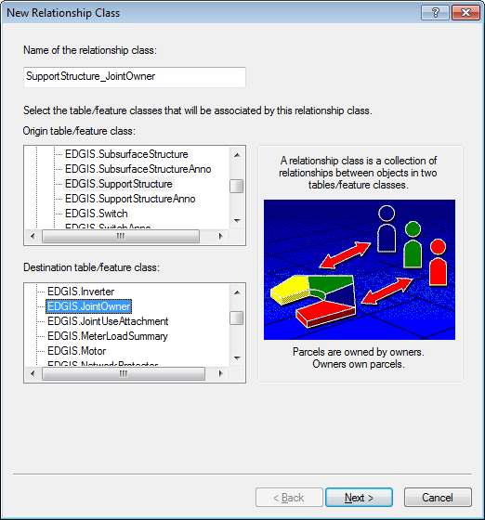

1. Click “Next”
2. Select “Composite relationship”

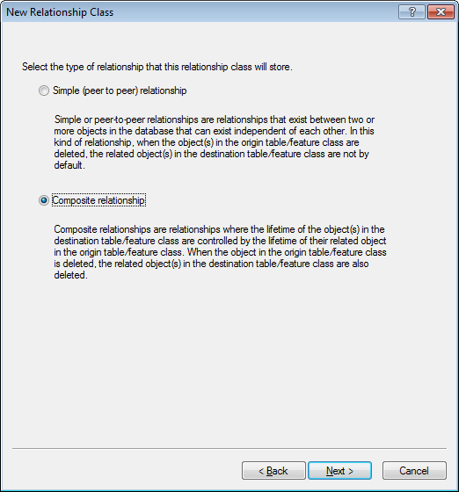

1. Click “Next”
2. Set the “Destination table/feature class” label = ‘Joint Owner’
3. Set the “Origin table/feature class” label = ‘Support Structure’
4. Leave “Direction” = ‘Forward’

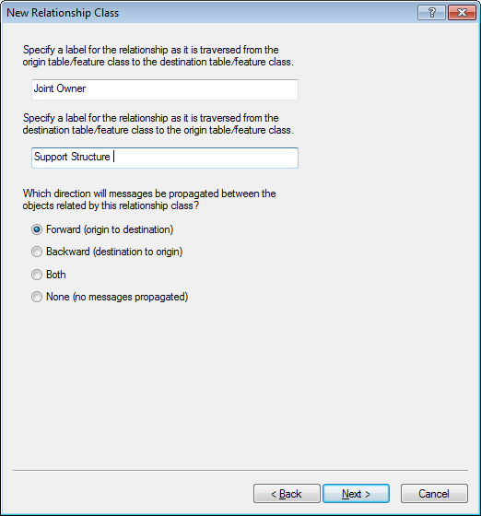

1. Click “Next”
2. Leave ‘1-M’ relationship

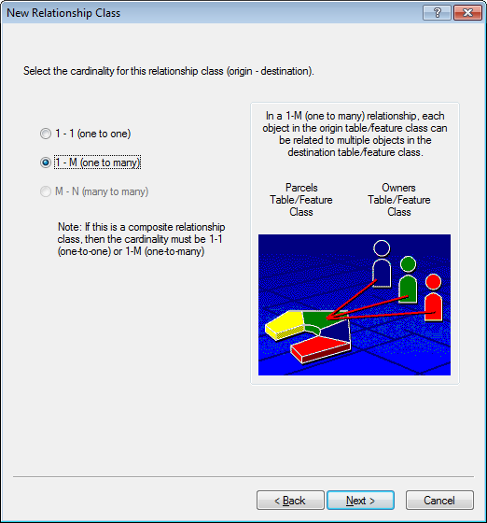

1. Click “Next”
2. Leave ‘No’ selected on the “add attributes” dialog.

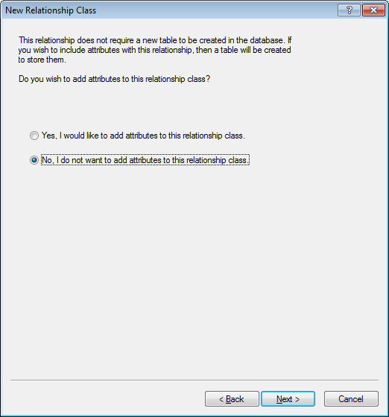

1. Select ‘GLOBALID’ for “primary key”
2. Select ‘STRUCTUREGUID’ for “foreign key”

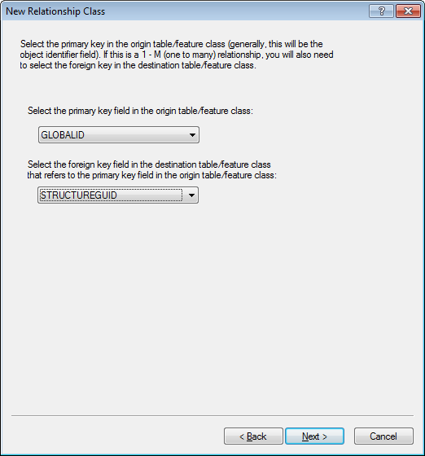

1. Click next
2. Verify all settings and spellings.

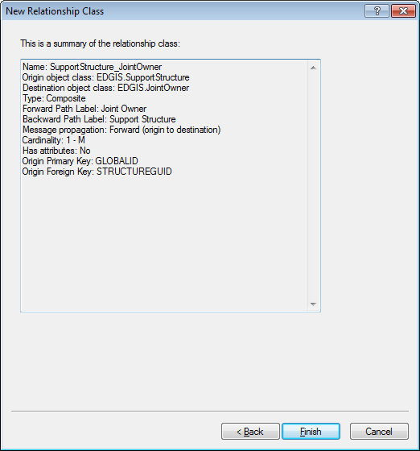

1. Click “Finish”

# Add Value of UNK to Domain: JobPrefixCode

[**Change Request 4784:**](http://edappgistfsprd1:8080/tfs/ElectricDistCollection/EDAMGIS/_workitems/edit/4784)**Need to add "UNKNOWN" to the JobPrefixCode Domain, or make the InstallJobPrefix optional**

1. Create a connection as EDGIS to the database
2. Right Click on the database connection and select “Properties…” from the menu.

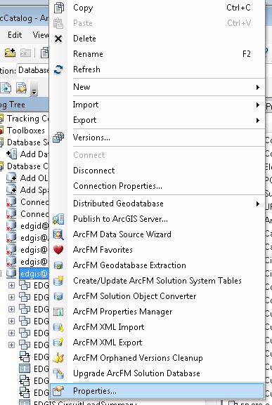

1. Locate the “JobPrefixCode” on the Domains tab of the “Database Properties” dialog

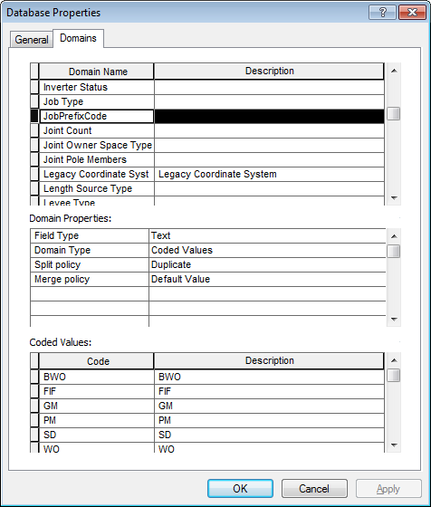

1. Add “UNK” code “UNK” description at the bottom of the domain list.

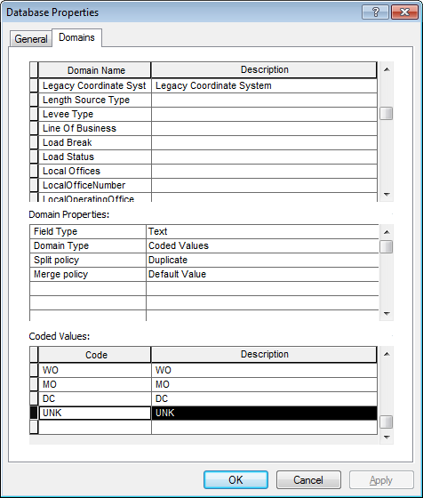

1. Click OK
2. This is now complete.

# Add Code/Value of PEC to Domain “Conductor Insulation - UG”

1. Create a connection as EDGIS to the database
2. Right Click on the database connection and select “Properties…” from the menu.



1. Locate the “Conductor Insulation - UG” on the Domains tab of the “Database Properties” dialog

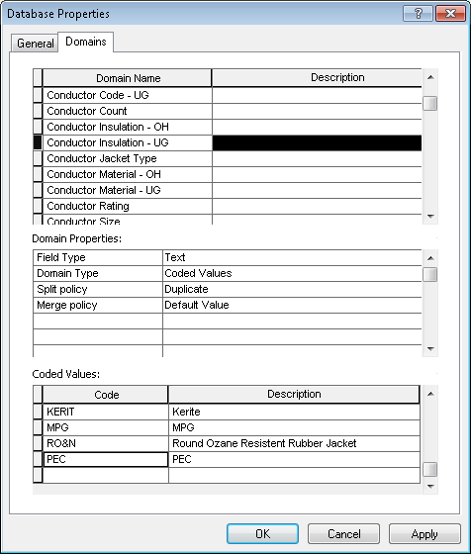

1. Add “PEC” code “PEC” description at the bottom of the domain list.
2. Hit “OK”
3. This is now complete.

# Modify Privileges For Electric Dataset

1. In order to view/write to the table we have dropped and re-created, we will need to enable privileges on them. Apply privileges to the Electric Dataset following the process below. Use the below table to reference the permissions that need to be applied (detail on how to use the table is provided further below).

|  |  |  |
| --- | --- | --- |
| Role | View | View & Edit |
| SDE_EDITOR | ConversionFeaturesDataset | All other datasets  *All EDGIS tables |
| SDE_VIEWER | All datasets  *All EDGIS tables |  |
| DAT_EDITOR | All other datasets  *All EDGIS tables | ConversionFeaturesDataset |
| **DATACONV | All datasets  *All EDGIS tables |  |
| **\*   = Except** EDGIS.*_BUILDERR & EDGIS.PGEDATAMODELVERSION  **\*\* = ONLY** QxQ & MxQ instances | | |

1. To do this, right click the ElectricDataset and select Privileges. Key in the first role, “SDE_EDITOR”, into the “User” field.

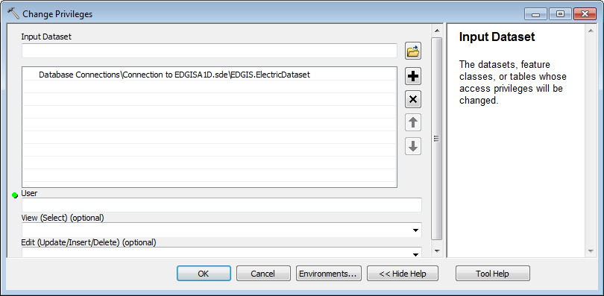

1. Select the dropdown for the View field and click “GRANT”.

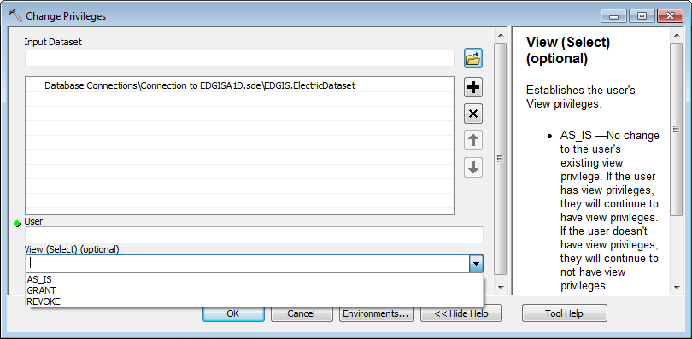

1. Select the dropdown for the Edit field and click “GRANT”.
2. Click OK to apply the privileges.
3. Open the Privileges dialog again and key in the second role, “SDE_VIEWER”, into the “User” field.
4. Select “GRANT” from the View dropdown.
5. Click OK to apply the changes.
6. Repeat steps 14-16 for the last two roles to finish applying privileges.

# Update Data Model Version Table

**Database Configuration:**

1. Open SQL Plus.
2. Log in using the same server and user as was used in section 2.  
     
   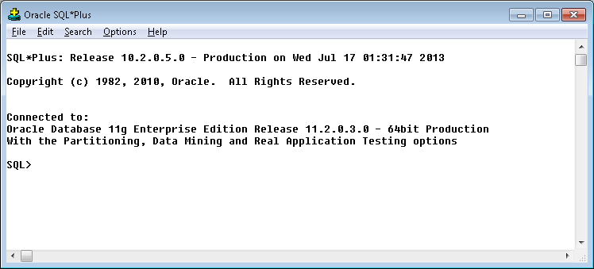
3. Run the SQL below:  
     
     
   **Next row in datamodelversion created because of last minute supportstructureanno change from Jon Ronat at 8:33AM on 7/17/13**

update pgedatamodelversion set currentidc='N' where currentidc='Y';

insert into pgedatamodelversion (OBJECTID, CURRENTIDC, DATEAPPLIED, APPLIEDBYPERSONNAME, MODELVERSION) values (28,'Y',sysdate,'Don Peaslee','7.5.5 GOLD CR8872');

# Known Issues

*-When following the document and changing the X/Y offsets there will be a warning about symbols being out of date and the symbol number in the symbol table changing. Please disregard this message. – Rob Rader 7/19/2013*

*- OK prompts for confirmation have been left out of the document. – Rob Rader 7/19/2013*

<Please List any other issues encountered here while following the document>